GREATEST NUMBER IN AN ARRAY

# EXP NO : 08

## AIM:

## To find the largest number from an array using 8085 processor.

## ALGORITHM:  1.  Load the address of the first element of the array in HL pair.  2.  Move the count to B register.  3.  Increment the pointer.  4.  Get the first data in A register.  5.  Decrement the count.  6.  Increment the pointer.  7. Compare the content of memory addressed by HL pair with that of A register.

## 8.  If carry=0, go to step 10 or if carry=1 go to step 9  9.  Move the content of memory addressed by HL to A register.  10.  Decrement the count.

## PROGRAM:  LXI H,2001 MOV C,M  DCR C  INX H  MOV A,M  LOOP1: INX H  CMP M  JNC LOOP  MOV A,M  LOOP: DCR C  JNZ LOOP1  STA 2010 HLT

## INPUT:

## 

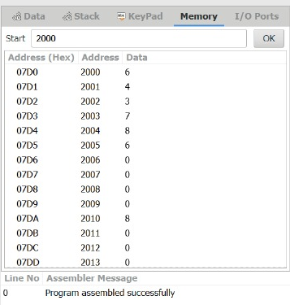

## OUTPUT:

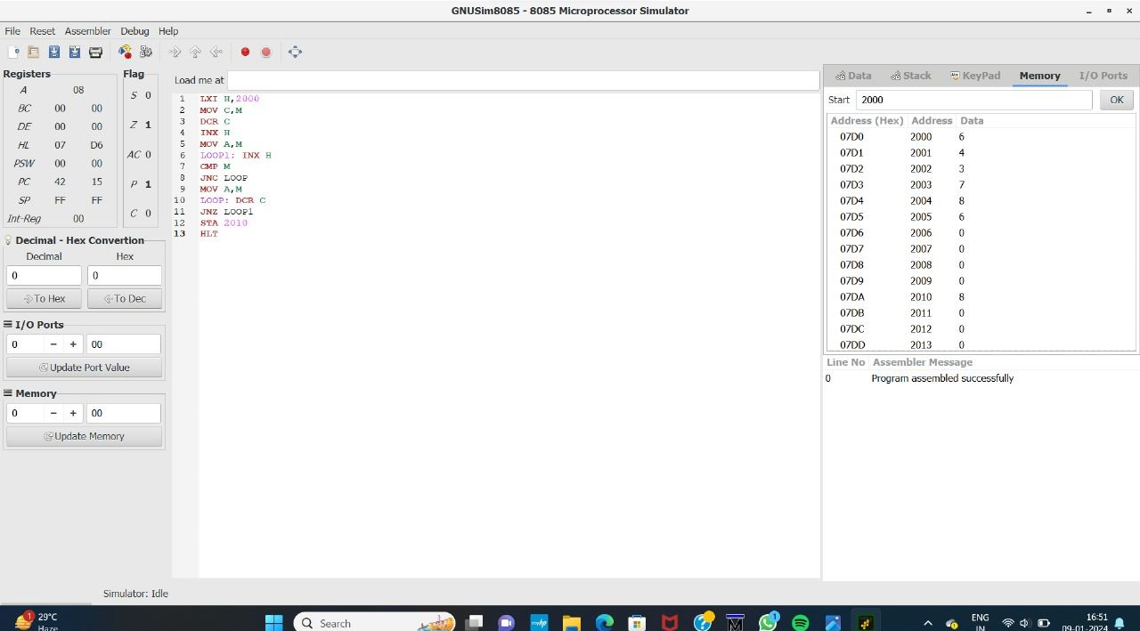

## RESULT:

Thus the program was executed successfully using 8085 Processor.